OPERATING SYSTEMS AND SYSTEMS PROGRAMMING
Practical 8a&b

2520030159 – hema sri
8a.
Develop a program using malloc(), calloc(), realloc(), and free(). Monitor memory allocation behavior and identify memory leaks using Valgrind.
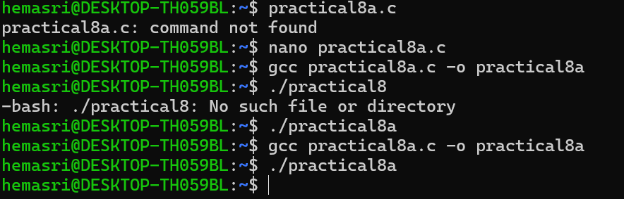
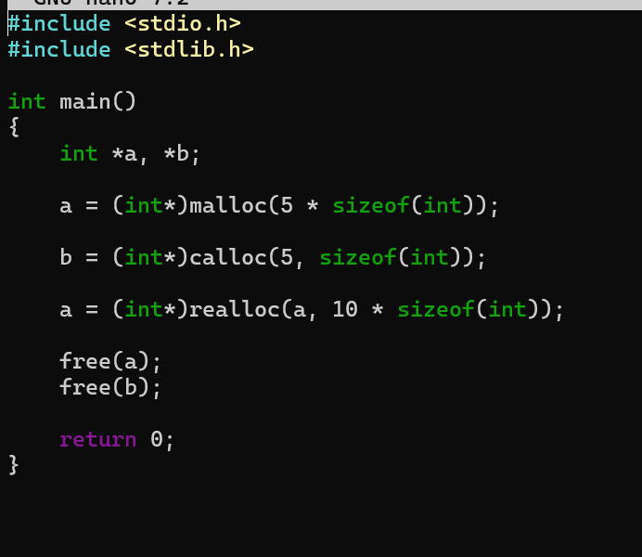

8b.
Develop a program that demonstrates Copy-on-Write behavior after a fork(). Analyze memory usage before and after modifying data in the child process.
